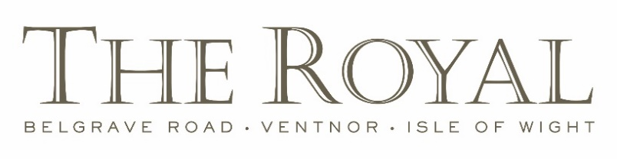

Dinner Menu

Vegetarian/Vegan menu available on request

Please discuss with our staff if you have any allergies or intolerances.

Please note all ingredients including gluten, nuts, sesame and other known allergens are used in our kitchen, therefore, there is a slight risk of cross contamination

Starters

Soup of the Day £7.00

Gallybagger Cheese Soufflé, Caramelised Cauliflower, Crispy Shallot £8.75

Jerk Salmon, Salsa Negro, Pickled Chilli, Mango Salsa, Coriander £7.95

Miso Glazed Pork Cheeks, Sweet Potato, Lime, Black Sesame £8.75

Torched Mackerel Fillet, Smoked Celeriac, White Grapefruit, Sea Purslane £7.95

Main Courses

Butter Poached Cod, Beef Fat Chips, Minted Peas, Crispy Capers, Dill Emulsion, Zesty Scraps £19.50

Halibut Supreme, Beetroot Risotto, Whipped Ricotta, Basil £23.50

Salmon Fillet, Creamed Saffron Leeks, Watercress, Poached Egg, £19.50

Confit Pork Belly, Baby Leek, Cauliflower Beignet, Chicken Stock Emulsion £18.95

Roast Breast of Chicken, Butternut Velouté, Herb Gnocchi, Girolles, Caramelised Goats Cheese £21.25

Beef Fillet Steak £32.00/ Sirloin Steak £24.00

all our steaks are 8oz from Isle of Wight farms and are served with Triple Cooked Chips,

Confit IOW Tomato, Chestnut Mushrooms, Bearnaise Sauce or Confit Garlic Butter

Side Orders

All £4.00 each

Buttered Potatoes, Herbs | Triple Cooked Chips | Living Larder Vegetables

Desserts

The Royal Eton Mess, Raspberry Sorbet £7.95

Dark Chocolate Brownie, Maple and Pecan Ice Cream £7.95

Vanilla Creme Brûlée, Strawberries, Madeleines £7.95

Clotted Cream Rice Pudding, Summer Fruits, Walnuts £7.95

Lemon Parfait, Thyme, Ginger £7.95

Selection of our Homemade Ice Creams and Sorbets £7.95

Selection of Three Isle of Wight Cheeses, Oaties, Grape & Shallot Chutney £9.00